Precedents- Use the URL below to find 5 precedents set by Washington during his administration and explain them in your own words.  http://www.mountvernon.org/research-collections/digital-encyclopedia/article/presidential-precedents/ | Domestic Affairs- Using the URL below, explain the following four terms are and how Washington enacted (used) them during his time as president. Be sure to be descriptive and use your own words.  http://millercenter.org/president/washington/essays/biography/4
1.  2.  3.  4.  5. | National Bank-  Judiciary Act of 1789-  Taxes-  Whiskey Rebellion (“War over whiskey”) -
Foreign Affairs- Using the URL below, explain the following five terms or situations are and their significance. Think about how these decisions came to shape U.S. foreign policy.  http://millercenter.org/president/washington/essays/biography/5 | 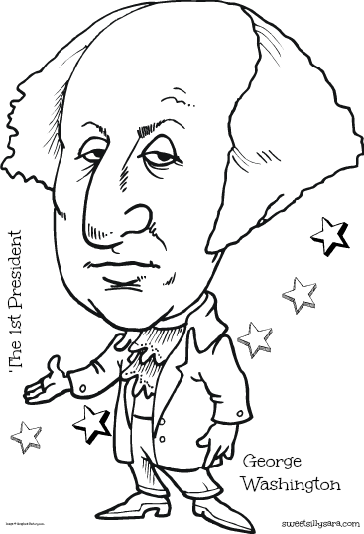  Extra Space
“Citizen” Genet-
Proclamation of Neutrality-
Jay’s Treaty (and the problems with it)-
Interactions with Barbary Coast Pirates-
Interactions with the Spanish-

